

Basic information on the Core Plan series 2026

Main differences on the 3 Core options:
- Classic Core plan:
Your plan pays out at 200% of the DHR in hospital. Can use any private hospital in the country.
The Classic Delta plan is exactly the same as above except that members have to use the network of Delta hospitals for planned or elective procedures to avoid the R11,100 upfront co-payment, as well as the Delta Day Surgery network for listed day surgery procedures. Please note, these networks do differ.

- Essential Core plan:
Your plan pays out at 100% of the DHR in hospital. Can use any private hospital in the country.
The Essential Delta plan is the same as above except that members have to use the network of Delta hospitals for planned admissions to avoid R11,100 upfront co-payment, as well as the Delta Day Surgery network for listed day surgery procedures. Please note, these networks do differ.

- Coastal Core Plan:
Your plan pays out at 100% of the DHR in hospital. For planned procedures you can use any private hospital in the coastal area to avoid a 30% co-payment. For medical emergencies, any private hospital can be used.

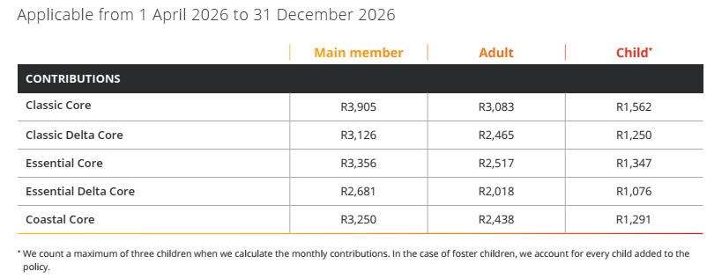

Below is a summary of Core plan benefits but please see the full Core plan brochure for more detailed information.

Hospital Cover
- Hospital cover is unlimited on all Discovery plans subject to authorization.
- The Coastal plans allow access to any hospital in a coastal province for planned or elective procedures and any hospital in the event of an emergency. If you choose to have a planned procedure in a non-coastal region there will be a 30% co-payment. You must live in the coastal region to qualify for any of the coastal plans.
- Members on Coastal plans need to inform Discovery within 3 months should they move and no longer reside in a coastal province.
- Essential and Coastal plans will pay at 100% of the tariff, Classic plans at 200% in-hospital. By using a Discovery network specialist, you will ensure there are no shortfalls. The list can be found on the Discovery website or you can contact our offices for assistance.
Should the specialist charge above the tariff rate for your plan, you will be financially responsible for the difference. It is highly recommended that gap cover be taken to cover this potential shortfall. This will pay for shortfalls in your medical aid tariffs up to a limit as well as other shortfalls like co-payments (plan dependent). Speak to us to find out more.
- The Trauma Recovery Extender benefit applies on the Core plans.
- You have cover for a defined list of procedures in one of Discovery’s Day Surgery Network. If the procedure is performed outside of this network, an upfront co-payment of R7,250 will apply (R11,100 on Delta plans).
- Co-payments:
  - R8,000 (R4,650 for day clinic within network) co-payment for all investigative scopes done in hospital. If both a gastroscopy and colonoscopy are performed in the same admissions these amounts are R9,950 (R5,700 day clinic within network) respectively.
  - There is a co-payment for in hospital dentistry of R3,470 (R1,550 day clinic) for members under 13 and R8,950 (R5,750 day clinic) for those over 13 (should you have the appropriate gap, you will be reimbursed this co-payment).

- IMPORTANT to note there is no cover for diagnostic MRI & CT scans not related to admission on any Core plans. Scans are only covered if related to your admission. No neck or back scans are covered.

Day to Day Benefits (Out of Hospital):
- There is no out-of-hospital cover on the Core plans and all day-to-day expenses will need to be self-funded by the member.
- Please note that because of there being no day-to-day cover, there is no cover for MRI/CT scans. On Saver plans it is covered by the scheme with a co-payment, which you can then claim from gap cover.

Maternity benefit: (covered on all plans paid from risk benefit and not MSA)
- Cover during pregnancy – 8 antenatal consults with gynae, GP or midwife, one NIPT test, 2 ultrasounds, 5 pre-natal/post-natal classes and a defined basket of blood tests.
- Cover 2 years after birth – 2 visits to Discovery GP/pediatrician/ENT, 6-week post birth consult with GP/gynae, one nutritional assessment with dietician, 2 mental health consultants and 1 lactation consultant.
- You can see more details here.

Chronic Medication:
  - Chronic medication is covered subject to a list of formularies provided by Discovery. Should you not be able to utilize the formulary, Discovery will pay a rand amount, and you will need to pay the difference. There are 27 chronic conditions covered on the Core plans.
  - Delta plan members must use Med-Express for all chronic medication to avoid a 20% co-payment.
  - In 2019 Discovery introduces new condition specific care programs for HIV Care, Cardio Care, Diabetes Care and Mental Health Care.

Screening Benefit:
- A number of preventative tests such as pap smear, mammograms, prostrate screening and various health screening blood tests are covered by Discovery.

Oncology (Cancer) Cover:
- Unlimited cover for cancer on the Discovery oncology approved care program, otherwise you are covered for the first R250,000 of approved cancer treatment over a 12-month cycle.
- Above this amount, cover is still unlimited but subject to a 20% co-payment. Gap cover can cover these co-payments up to a set limit.

International Travel benefit:
- Cover for a period of 90 days for each person for medical emergencies when travelling outside SA. This is limited to R5 million. Member must advise Discovery when travelling abroad.
  - Members have emergency medical evacuation cover from certain sub-Saharan African countries.

Personal Health Fund:
- Members accumulate funds towards their Personal Health Fund every time they complete a health action in their personal health pathway, which they can then use for day-to-day medical expenses.
- The maximum fund allocation is defined by the member’s plan choice amd the family structure of the membership, from R1,000 per family on the KeyCare plans up to R10,000 on the Comprehensive plans.
- Read more about this benefit here.
NEW
- Introducing Sleep Actions and Personal Health Challenges in 2026. More ways to earn rewards and boost your Personal Health Fund.

There are limits on certain health care services:
- Cochlear implants, auditory brain implants & processors, hip, knee & joint prosthesis, prosthetic devices for spinal surgery, mental health, alcohol & drug rehab, terminal care, chronic dialysis.

General Exclusions:
- Discovery will not cover any expense, direct or indirect, related to any of the general or specific exclusions.
- Cosmetic procedures or treatments, otoplasty, breast reduction/ enlargements, obesity, frail care, infertility, self-inflicted illness/ injury, alcohol/ drug/ solvent abuse, willful participation in war, terrorist activities etc.
- Experimental, unproven and unregistered treatments, search and rescue and any cost for which a third party is legally responsible.

Underwriting criteria worth noting when considering a medical aid
- Late joiner penalties may be imposed to a person older than 35 who has not been covered by a medical aid for specified period.
- The scheme may impose a 3-month general waiting period and/or 12-month condition specific exclusion dependent on the questions answered on your application form.
- Gap cover will have a standard 3-month waiting period for any non-emergency procedures and a 12-month waiting period on pregnancy.
- Very important that full disclosure is made with your medical aid application. Non-disclosure can result in repudiation of claims and immediate cancellation of the plan by Discovery Health.

IMPORTANT – please note that while every effort is made to ensure the accuracy of these summaries, the Discovery plan guides take preference and must always be referred to. This has been linked to at the top of this summary or can be found on our website: www.delfs.co.za

E&OE

